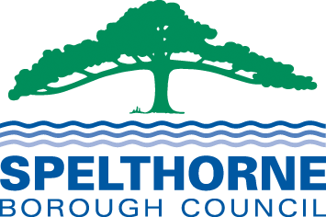

Spelthorne

Better Neighbourhoods

Grant Scheme

Handbook

2025-2026
Spelthorne Better Neighbourhoods Grant Scheme

Introduction

The Council Corporate Plan prioritises Community, putting communities at the heart of everything we do, building strong relationships with our residents and businesses, and helping to forge links within those communities. Local community projects are crucial as they help to keep people connected with others and foster a variety of benefits. Ward councillors have a key role to play in helping to achieve these community benefits by listening to and supporting their local communities to achieve change.

Ward councillors have each been allocated £1,000 (2025-2026) to spend in their wards through the Better Neighbourhoods Grant Scheme. This handbook sets out the principles and rules for the scheme, which are intended to make it transparent, accountable, and auditable.

Purpose of the scheme

The key aims of the scheme are:

- To promote the role of councillors as community leaders.
- To lead to better engagement between residents, community organisations and the Council.
- To enable the Council to respond to community needs.
- To promote well-being, benefit to those less fortunate and alleviate deprivation.
- To respond to the developing neighbourhood agenda, including promoting green initiatives.
- To enhance the look of the Borough.

Outline of the process

- Councillors identify suitable cause/s to support.
- In cases where it is proposed to match fund the SCC local members scheme, discussion must take place with the appropriate SBC Committee Chair in the first instance.
- Councillors complete an application form giving full details of what causes they wish to support, how much funding is required, how it supports the scheme’s key priorities.
- The CX Secretariat recommends the grant for approval by the Leader of the Council and the Chief Executive.
- A BACS payment is made to the recipient organisation and a letter of confirmation sent to the recipient. The councillor can present the award letter in person if requested.
- Publicity will be arranged if the councillor wishes.
- Recipient organisations will be asked to send verification of the use of the grant.

How the grants can be used

The following criteria must be met for Better Neighbourhoods Grants to be awarded:

- Funds must be spent to support one or more of the Council priorities. Please see below:

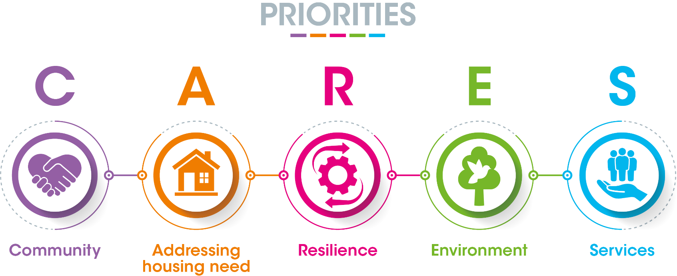

- Grants should be of a capital or one-off nature rather than proposals for revenue or ongoing expenditure.
- Grants should have no long-term revenue implications for the Council.
- Grants are generally to be made to community/voluntary organisations, but it is possible that they could be used to fund Council services to provide “quick fixes” in neighbourhoods where funds would not otherwise be available (in this case, the councillor would need to agree the proposal with the Group Head before submitting an application).
- Funds must be used to support more than one person who lives or works in the councillor’s ward.
- Organisations can only receive one grant per year (although more than one councillor may choose to contribute funds to the grant).
- There must be an interval of one financial year before an organisation/project can qualify to receive a second Better Neighbourhoods Grant for a specific purpose.
- Organisations/projects can receive grants in consecutive years if the money is used for distinctly different purposes.
- Grants can be used for new or existing projects and can be used to provide “match-funding” to support projects that have already received part of their funding from other organisations.
- Recipients may or may not already be in receipt of Council funding.
- Councillors within a ward may choose to combine their allocations. In addition, councillors in different wards may combine their allocations so long as there is evidence that the expenditure will benefit residents of each ward. Each contributing councillor must sign the application form. If approved, one payment will be made to cover the whole grant.

How the grants cannot be used

Better Neighbourhoods Grants cannot be used:
- For party political purposes.
- Where expenditure is contrary to Council policy.
- Where the councillor making the grant has a personal or prejudicial interest.
- Where the project is unlawful or improper.
- To support profit-making organisations.
- To support Residents’ Associations with running costs and day to day expenses.
- To mitigate shortfalls by other funders or income streams (e.g. GP surgeries, other NHS services or Surrey County Council).
- To support animal charities or purchase and care of school pets or similar
- To purchase alcohol and refreshments for street parties e.g. Jubilee celebrations. Other street party costs are acceptable.

While grants can be made during an election timetable, no assistance with publicity can be given due to pre-election period rules.

How the grants will be made

Applications for grants must be made by 28 February 2026 to allow time for approval and processing before the end of the financial year. Any unspent/surplus grant monies will be transferred into the Council’s Grants budget and allocated appropriately through the grants panel.
Councillors are responsible for checking that the potential recipient organisation has sufficient need of the funding and is able to complete the proposed project. In deciding on a project to support, councillors should ensure that the following risks are minimised:
- Reputational risk to the Council (should the organisation misuse the funds).
- Health and safety risk.

Application form

Councillors must complete a Better Neighbourhood Grant application form in all cases either electronically or via a hard copy. The application form and this handbook, are available on the council website via this link. Better Neighbourhood Grants - Spelthorne Borough Council. Councillors must ensure that the grant recipients bank details and email address are accurately recorded on the form. If completed electronically an electronic signature/s must be used. If several councillors are contributing to a project, they all must sign the form. Once the form has been completed the councillor must return it to the Chief Executives Secretariat bng@spelthorne.gov.uk. *Please note that we cannot accept forms submitted by members of the public*.

The councillor(s) are responsible for passing a copy of the Privacy Notice to the applicant. (This is the fourth page of the application form). This ensures the Councillors and Council comply with GDPR legislation.

The completed application form will be forwarded to the Leader of the Council and the Chief Executive who will consider whether to approve the release of the funds. Insufficient detail on the application form may lead to it being declined or a delay in payment. The final decision rests with the Leader of the Council and Chief Executive.

Release of funds

Once the grant has been approved, a BACS payment will be made to the recipient group and a letter of confirmation sent to the recipient. If preferred, the councillor may present the letter in person. The councillor will be informed of the balance of their individual budget.
The councillor should contact the Communications Department regarding any publicity they and the recipient group would like to arrange.

Follow-up

External recipient organisations will be asked to send evidence of expenditure (for example, copies of receipts and invoices) for audit purposes to bng@spelthorne.gov.uk

Further information

If you have any queries about the scheme, please contact CX Secretariat (Dawn Richards / Jayne McEwan) on 01784 446395 or bng@spelthorne.gov.uk.

